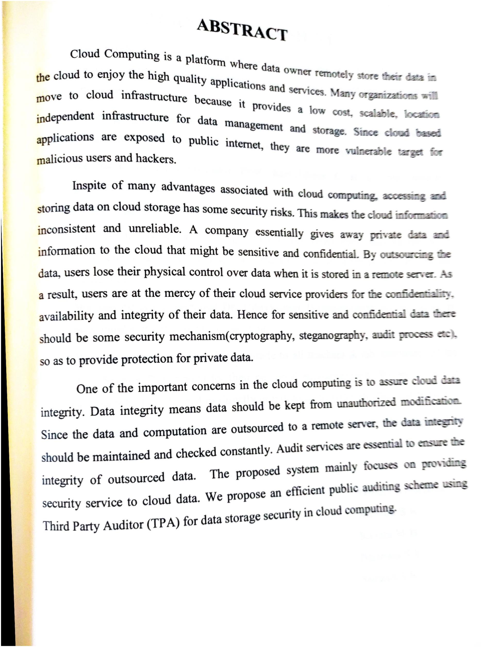

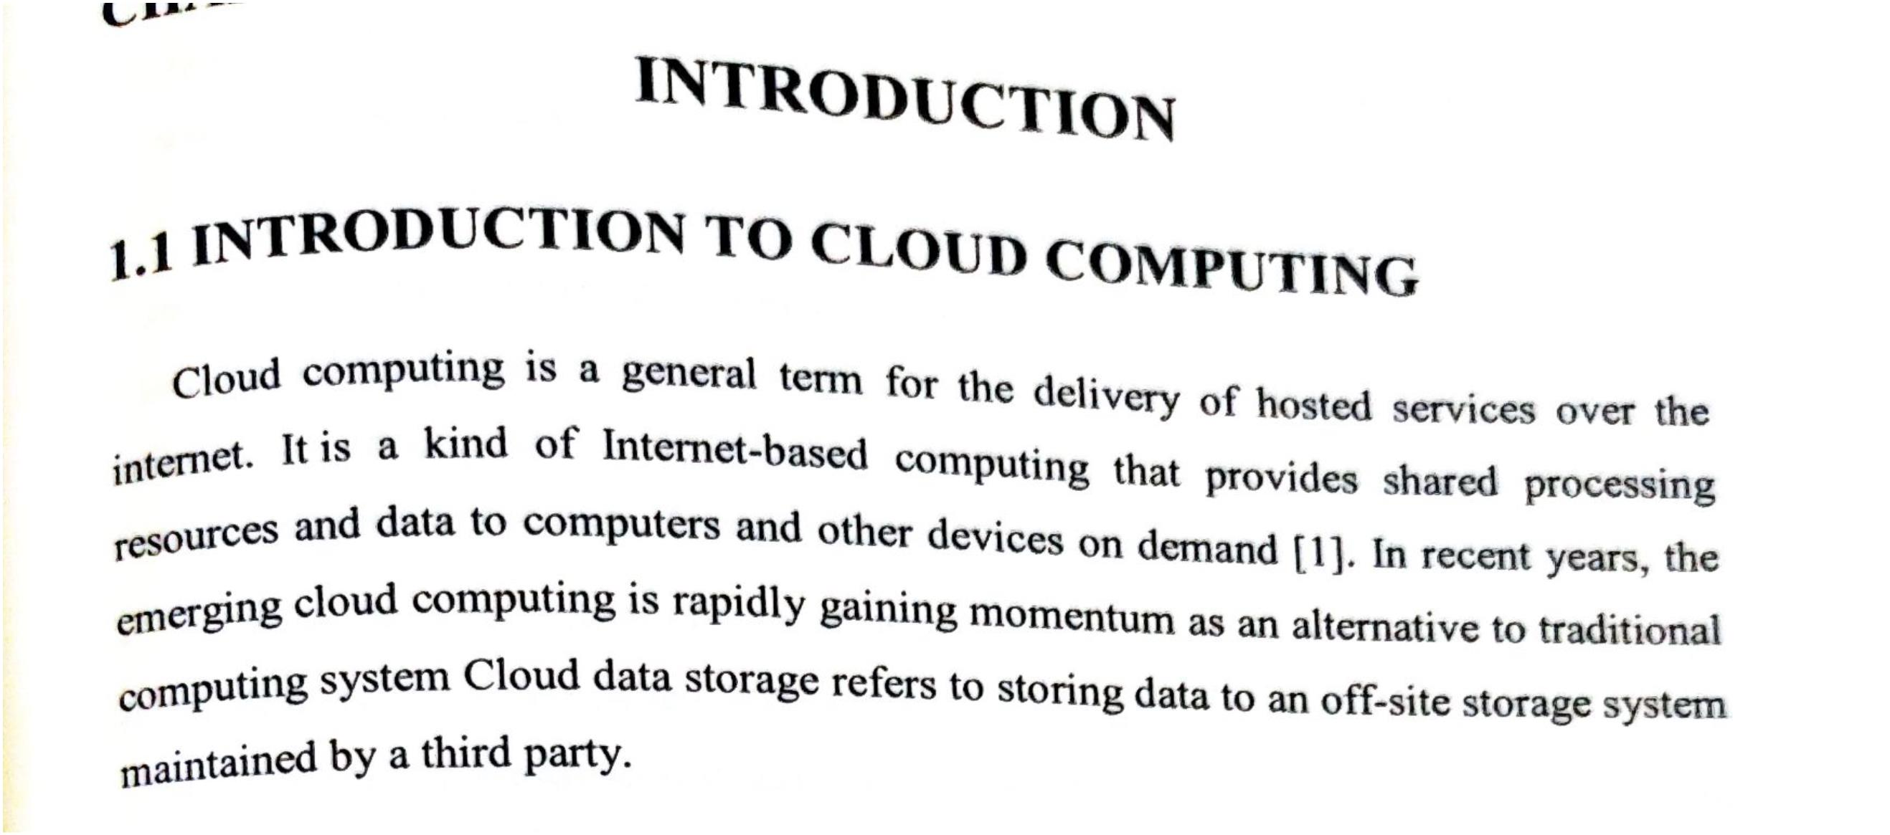

Only two pages were converted.

Please **Sign Up** to convert the full document.

[**www.freepdfconvert.com/membership**](https://www.freepdfconvert.com/membership)

